STEMI in a Patient With Severe Thrombocytopenia
Jan 31, 2017 | Karam Ayoub, MD; Srikanth Vallurupalli, MD
Share via:
AddThis Sharing Buttons
Share to Facebook
Share to TwitterShare to LinkedInShare to EmailShare to More

Font Size
A
A
A
A 79-year-old male patient with a history of coronary artery disease and complicated percutaneous coronary intervention (PCI) (covered stent to proximal left anterior descending artery [LAD] to treat perforation 4 years prior to presentation) and multiple myeloma presents to the emergency department with acute substernal chest pain and shortness of breath for 1 hour. He had undergone a stem cell transplant 10 days prior and was receiving chemotherapy at the time of presentation. His clopidogrel was stopped a week prior to admission due to thrombocytopenia. His medications at presentation included aspirin and rosuvastatin. His blood pressure was 94/70 mmHg; heart rate was 84 bpm; and respiratory rate was 16/min. The initial electrocardiogram showed ST elevation in the anteroseptal leads and I, aVL along with anterior hyperacute T waves and reciprocal changes in inferior leads, suggesting a proximal LAD occlusion (Figure 1). A day prior to presentation, his platelet count was 38,000/mcl. He went emergently for angiography, which showed the following abnormality in the LAD artery (Figure 2).
Figure 1
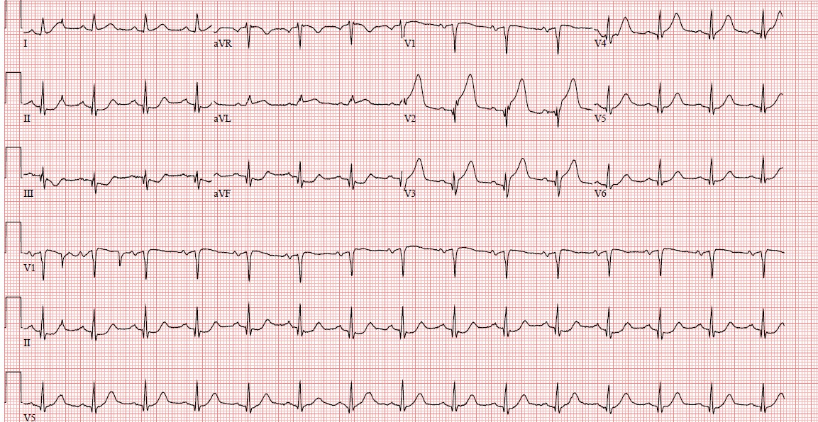
Figure 2
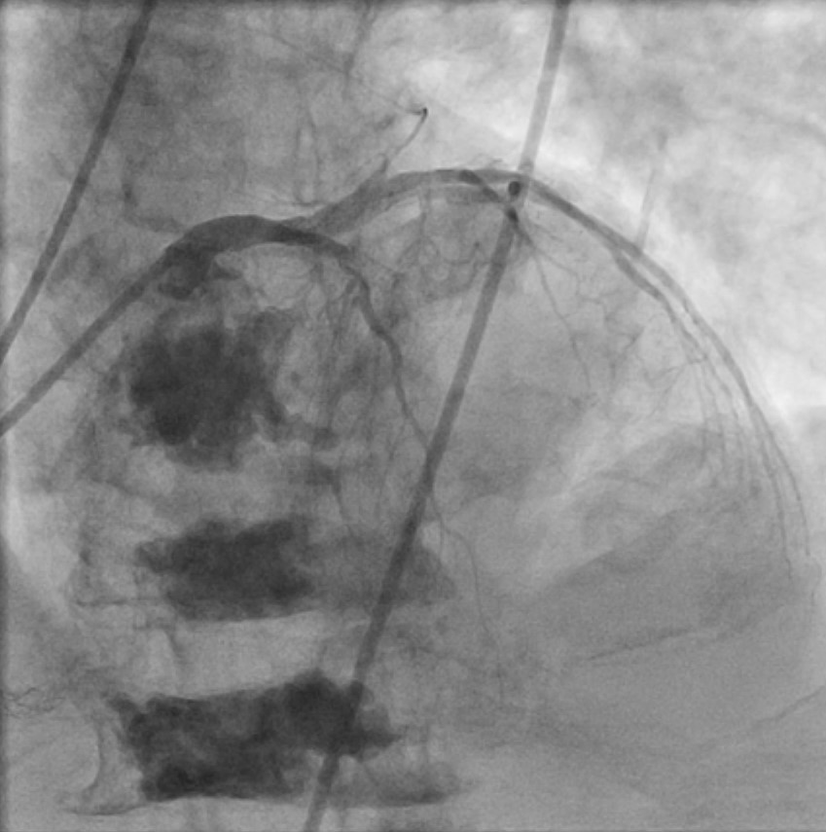

The correct answer is: D. Dual antiplatelet therapy (DAPT) use is not prohibited after PCI in patients with moderate-severe thrombocytopenia.
Platelets play a significant role in the pathogenesis of ACS. However, thrombocytopenia is not protective against ACS.¹ In thrombocytopenia, platelets are often larger and more reactive despite being lower in number. Answer A is thus a false statement.
The prognostic significance of baseline thrombocytopenia in patients with ACS is increasingly being recognized. Randomized trials routinely exclude patients with moderate-severe thrombocytopenia (<100,000/mcl). However, even mild baseline thrombocytopenia (100,000-150,000/mcl) can affect the prognosis of patients presenting with ACS. In a pooled analysis of HORIZONS-AMI (Harmonizing Outcomes with Revascularization and Stents in Acute Myocardial Infarction) and ACUITY (Prospective, Randomized Comparison of Heparin Plus IIb/IIIa Inhibition and Bivalirudin With or Without IIb/IIIa Inhibition in Patients with Acute Coronary Syndromes) trials, baseline mild thrombocytopenia was associated with similar clinical outcomes at 30 days but worse 1-year clinical outcomes (significantly higher risk of both cardiac and non-cardiac death).² The statement in answer B is thus false. The underlying mechanism is unknown, but mild thrombocytopenia may reflect more severe cardiac and non-cardiac comorbidities.
Treatment of ACS in patients with moderate-severe thrombocytopenia (platelet count <100,000/mcl) is challenging because of concerns for bleeding as well as the severity of underlying condition that caused thrombocytopenia (end-stage liver disease, malignancy, etc.). Evidence is limited to retrospective cohort studies.^{3,4} However, patients with severe thrombocytopenia (<50,000/mcl) were underrepresented (only 6% of the thrombocytopenia cohort in the study by Raphael et al.). The statement in answer C is thus false. In these studies, DAPT was not associated with a prohibitive risk of bleeding, although the need for red blood cell and platelet transfusions was higher. Answer D is the true statement and thus the correct answer. The 2016 Society for Cardiac Angiography and Interventions expert consensus statement on management of cardio-oncology patients is an excellent resource for management of these often-challenging patients.¹
In this case, angiography revealed very late stent thrombosis of the covered stent. There was no significant flow limiting restenosis after manual aspiration thrombectomy, so stenting was deferred. DAPT was resumed after a loading dose of clopidogrel (600 mg). At 3-year follow-up, the patient remains on DAPT with no interim significant bleeding or thrombotic complications. This case also illustrates the high long-term risk of target vessel failure and the need for prolonged DAPT in patients with covered stents.
References
- Iliescu CA, Grines CL, Herrmann J, et al. SCAI Expert consensus statement: Evaluation, management, and special considerations of cardio-oncology patients in the cardiac catheterization laboratory (endorsed by the cardiological society of india, and sociedad Latino Americana de Cardiologıa intervencionista). Catheter Cardiovasc Interv 2016;87:E202-23.
- Yadav M, Généreux P, Giustino G, et al. Effect of Baseline Thrombocytopenia on Ischemic Outcomes in Patients With Acute Coronary Syndromes Who Undergo Percutaneous Coronary Intervention. Can J Cardiol 2016;32:226-33.
- Raphael CE, Spoon DB, Bell MR, et al. Effect of Preprocedural Thrombocytopenia on Prognosis After Percutaneous Coronary Intervention. Mayo Clin Proc 2016;91:1035-44.
- Overgaard CB, Ivanov J, Seidelin PH, Todorov M, Mackie K, Dzavík V. Thrombocytopenia at baseline is a predictor of inhospital mortality in patients undergoing percutaneous coronary intervention. Am Heart J 2008;156:120-4.
n

